**SMART VILLAGE**

CREATED BY:

PRUTHVI SONI

AKIL SHAKIH

**C**

**Academic Year: 2015-2016**

**(Affiliated to Gujarat Technical University)**

**C E R T I F I C A T E**

This is to certify that **Mr. Pruthvi Soni & Akil Shakih** having **Enrollment No: 146050316024, 146050316024** has completed Part-I UDP Project work having title “**SMART VILLAGE”**. He has undergone the process of smart village, literature survey and problem definition. He is supposed to carry out the residue UDP Part-II work on same problem during Semester-V for the final Fulfillment of the UDP work which is Prerequisite to complete Diploma Engineering in Information Technology.

**GUIDED BY: Head of Dept:**

**MR. Rakesh Varma Prof. R. J. Parmar**

**Lect. I.T Dept.**

**Sign: Sign:**

**External Examiner:**

**Sign:**

**ABSTRACT**

Smart Village is a project which aims in developing a computerized system to give information on the village .This project has many features which are generally not available like it gives information about the village, population of the village, i.e. how many numbers of males ,females and children .It also provides the information about nearby village transportation facility near by city etc. .It also has a facility of admin login through which the admin can monitor the whole system .It also has facility of an FAQs where people can put up their quires . It also shows the map of the village.

This project can be access throughout the internet and can be accessed by anyone who has a internet connection.

Smart village project is implemented in php platform as front end and Microsoft sql as back end.

Main objective of our project is to provide information about the village so that it can be easily for people to go through it and it can also government for maintaing records.

Overall this project of ours is being developed to help the village as well as government of Gujarat state to maintain the records in the best way possible and also reduce the human efforts.

**ACKNOWLEDGEMENT**

**I am thankful to all the people who joined as part of making this journey of fulfilling of this project into working model. I am grateful to Gujarat Technological University for giving us a wonderful platform through “SMART VILLAGE” for exploring our software developing skills during making of this project.**

**I am also thankful to my internal guide MR. Rakesh Varma as well as other staff members of Information Technology DEPARTMENT, BBIT, V.V.NAGAR for their constructive and helpful inputs.**

**I am student of 5th semester also thankful to our classmates and others who helped us directly or indirectly in solving problems and making my software project more efficient and working.**

**Pruthvi Soni Akil Shakih**

**(146050316024) (146050316029)**

INDEX

|  |  |  |  |
| --- | --- | --- | --- |
| NO. |  | Contents | Page No |
| 1. |  | **Introduction & Objectives of Project** | 1 |
|  | **1.1** | **Introduction of system** | 1 |
|  | **1.2** | **Scope of system** | 2 |
|  | **1.3** | **Objectives** | 2 |
| 2. |  | **Tools / Platform & Language** | 3 |
|  | **2.1** | **Hardware requirement** | 3 |
|  | **2.2** | **Software requirement** | 3 |
|  | **2.3** | **Tools/Technologies** | 3 |
|  | **2.4** | **Detail description of technology** | 7 |
| 3. |  | **Design of project** | 8 |
|  | **3.1** | **Screenshot** | 8 |
|  | **3.2** | **Process Phase** | 11 |
| 4. |  | **Advantages** | 12 |
| 5. |  | **Conclusion** | 12 |
| 6. |  | Bibliography | 12 |

Chapter: 1 **Introduction & Objectives of Project**

* 1. **Introduction Of The System**

A website is the collection of Web pages, images, videos and other digital assets that is hosted on one or serval Web server, usually accessible via the internet phone or a LAN.

This project can be used by the users to get the information about the village which are in our

Country. With the Help of this project any one access the details of the village if anyone want to know about the village than they can see without visiting the village without wasting their time.

The main objective of this project is to provide the better work efficiency, accuracy, reliability, feasibility. The error occurred could be reduced to nil and working conditions can be improved. A user can have various benefit’s of website on the smart village. one of the best thing is that a person can get the detailed information about the village at the door step.

A web Application accommodates the information regarding Smart Jitpura village Website.

The user will be able to search to Information about our village, can write blog in category, download information, see information of about village, and explore village people details,

Village details and author basic detail without log in to website.

This project contains information regarding village sarpanch, talati, village, nearby village details etc. It manage all information by using SQL Database and provide best facility through PHP

* 1. **Scope of the Website**

1. Create an integrated web site that projects a consolidated and consistent image.

2. To describe image of progressive, firmly grounded village serving the needs of the community.

3. To increase visibility of our services options.

4. To provide features that make the village urbanized.

5. To ensure technical support is in place to maintain the site.

6. Give people the ability to bypass the phone to contact the village.

1.3 **Objectives of the Website**

The proposed project is a website based project that can be implemented for any information to the user or organizations.

This website provides facilities for users to go through the complete village infrastructure that is agriculture status of the village, population of the village, literacy rate, education qualification etc.

This study has it primary objectives. The design of the website that will immense benfit to the people of the village as well as other user.

Other objectives of the project are:

* Consistent & quality content
* Service quality standards and maintenance (be able to support what works and what doesn’t)
* connect people with the village at their door step
* Capture member information for better care
* Enforce the timely and accurate report of smart village

**Chapter-2 Tools / Platform & Language**

**2.1** **Tools/Platform and language**

**Hardware requirement:**

* Web Server : Xampp [5.1.4]
* Web Browser : Internet Explorer, Morzilla, chrome
* Tools : Dream viewer 6.0
* Technology : PHP 4, PHP 5
* Database Server : My SQL [5.0.21]

**2.2 Software Requirements:**

* Google Chrome
* Notepad++

**2.3 Tools/Technologies:**

**Front end:** PHP

**Back end**: Microsoft SQL server

**Server**: Wamp Server

**Browser**: Google Chrome

**Editor**: Notepad++

**2.4Detail description of technology:**

**1.PHP**

PHPis a [server-side scripting](https://en.wikipedia.org/wiki/Server-side_scripting) language designed primarily for [web development](https://en.wikipedia.org/wiki/Web_development) but is also used as a [general-purpose programming language](https://en.wikipedia.org/wiki/General-purpose_programming_language). Originally created by [Rasmus Lerdorf](https://en.wikipedia.org/wiki/Rasmus_Lerdorf) in 1994, the PHP [reference implementation](https://en.wikipedia.org/wiki/Reference_implementation) is now produced by The PHP Development Team. PHP originally stood for Personal Home Page, but it now stands for the [recursive acronym](https://en.wikipedia.org/wiki/Recursive_acronym) PHP*:* HypertextPre-processor.

PHP is the large no of internet service providers (ISPs) and web hosting companies that support it. Today there are hundreds of thousands of developers using PHP, and its not surprising that there are so many, considering that several that several million sites are reported to have php installed.

 PHP is a cross platform technology and that once you have written your web page it’s easy to get it up and running on our web server but how does php compare with other technologies out there?.

PHP was specifically designed to rapidly create dynamic web content; Perl was not. As a result, Perl can sometimes be a complicated language that can become prohibitive for users who want to create web pages. comparing php with asp is a more balanced comparison, but then you have to pay for asp% and asp doesn’t work well on a variety of platforms it needs to be used on other proprietary for which you also must pay

Wamp:

Stands for "Windows, Apache, MySQL, and PHP." WAMP is a variation of [LAMP](http://techterms.com/definition/lamp) for Windows systems and is often installed as a [software](http://techterms.com/definition/software) bundle (Apache, MySQL, and PHP). It is often used for [web development](http://techterms.com/definition/web_development) and internal testing, but may also be used to serve live websites.

The most important part of the WAMP package is [Apache](http://techterms.com/definition/apache) (or "Apache HTTP Server") which is used run the [web server](http://techterms.com/definition/web_server) within Windows. By running a local Apache web server on a Windows machine, a web developer can test [webpages](http://techterms.com/definition/webpage) in a [web browser](http://techterms.com/definition/web_browser) without publishing them live on the Internet.

WAMP also includes [MySQL](http://techterms.com/definition/mysql) and [PHP](http://techterms.com/definition/php), which are two of the most common technologies used for creating [dynamic websites](http://techterms.com/definition/dynamicwebsite). MySQL is a high-speed database, while PHP is a scripting language that can be used to access data from the database. By installing these two components locally, a developer can build and test a dynamic website before publishing it to a public web server.

While Apache, MySQL, and PHP are open source components that can be installed individually, they are usually installed together. One popular package is called "WampServer," which provides a user-friendly way to install and configure the "AMP" components on Windows.

The acronym WAMP refers to a set of free [open source](http://www.webopedia.com/TERM/O/open_source.html) [applications](http://www.webopedia.com/TERM/A/application.html), combined with Microsoft Windows, which are commonly used in [Web server](http://www.webopedia.com/TERM/W/Web_server.htm) environments. The WAMP stack provides developers with the four key elements of a Web server:  an [operating system](http://www.webopedia.com/TERM/O/operating_system.htm), [database](http://www.webopedia.com/TERM/D/database.html), Web server and Web scripting software. The combined usage of these programs is called a server stack. In this stack, [Microsoft Windows](http://www.webopedia.com/TERM/M/Microsoft_Windows.html) is the operating system (OS), [Apache](http://www.webopedia.com/TERM/A/Apache_Web_server.html) is the Web server, [MySQL](http://www.webopedia.com/TERM/M/MySQL.html) handles the database components, while [PHP](http://www.webopedia.com/TERM/P/PHP.html), [Python](http://www.webopedia.com/TERM/P/Python.htm), or [PERL](http://www.webopedia.com/TERM/P/Perl.html) represents the dynamic scripting languages.

**Xampp:**

XAMPP  is a [free and open source](https://en.wikipedia.org/wiki/Free_software) [cross-platform](https://en.wikipedia.org/wiki/Cross-platform) [web server](https://en.wikipedia.org/wiki/Web_server) [solution stack](https://en.wikipedia.org/wiki/Solution_stack) package developed by Apache Friends, consisting mainly of the  [Apache HTTP Server](https://en.wikipedia.org/wiki/Apache_HTTP_Server), [MariaDB](https://en.wikipedia.org/wiki/MariaDB) [database](https://en.wikipedia.org/wiki/Database), and [interpreters](https://en.wikipedia.org/wiki/Interpreter_(computing)) for scripts written in the [PHP](https://en.wikipedia.org/wiki/PHP) and [Perl](https://en.wikipedia.org/wiki/Perl) [programming languages](https://en.wikipedia.org/wiki/Programming_language). XAMPP stands for Cross-Platform (X), Apache (A), MariaDB (M), PHP (P) and Perl (P). It is a simple, lightweight Apache distribution that makes it extremely easy for developers to create a local web server for testing and deployment purposes. Everything needed to set up a web server – server application (Apache), database (MariaDB), and scripting language (PHP) – is included in an extractable file. XAMPP is also cross-platform, which means it works equally well on Linux, Mac and Windows. Since most actual web server deployments use the same components as XAMPP, it makes transitioning from a local test server to a live server extremely easy as well.

Xampp is regularly updated to the latest releases of Apache, and PHP. It also comes with a number of other modules including OpenSSL, PHPmyadmin and more. Self-contained, multiple instances of Xampp can exist on a single computer and any given instance can be copied from one computer to another. Xampp is offered in both a full and a standard version.

**Web components or controls:**

**CSS:**

Cascading Style Sheets CSS is a style sheet language used to describe the presentation semantics (the look and formatting) of a document written in a mark-up language. Its most common application is to style web pages written in HTML and XHTML, but the language can also be applied to any kind of XML document, including plain XML, SVG and XUL.

CSS is designed primarily to enable the separation of document content (written in HTML or a similar mark-up language) from document presentation, including elements such as the layout, colours, and fonts. This separation can improve content accessibility, provide more flexibility and control in the specification of presentation characteristics, enable multiple pages to share formatting, and reduce complexity and repetition in the structural content (such as by allowing for table less web design). CSS can also allow the same mark-up page to be presented in different styles for different rendering methods, such as on-screen, in print, by voice (when read out by a speech-based browser or screen reader) and on Braille-based, tactile devices. It can also be used to allow the web page to display differently depending on the screen size or device on which it is being viewed. While the author of a document typically links that document to a CSS style sheet, readers can use a different style sheet, perhaps one on their own computer, to override the one the author has specified.

CSS specifies a priority scheme to determine which style rules apply if more than one rule matches against a particular element. In this so-called cascade, priorities or weights are calculated and assigned to rules, so that the results are predictable.

**Java Script:**

JavaScript is a prototype-based scripting language that is dynamic, weakly typed and has first-class functions. It is a multi-paradigm language, supporting object-oriented, imperative, and functional programming styles.

JavaScript was formalized in the ECMAScript language standard and is primarily used in the form of client-side JavaScript, implemented as part of a Web browser in order to provide enhanced user interfaces and dynamic websites. This enables programmatic access to computational objects within a host environment.

JavaScript's use in applications outside Web pages — for example in PDF documents, site-specific browsers, and desktop widgets — is also significant. Newer and faster JavaScript VMs and frameworks built upon them (notably Node.js) have also increased the popularity of JavaScript for server-side web applications.

**JQuery:**

JQuery is a cross-platform JavaScript library designed to simplify the client-side scripting oh HTML. JQuery is the most popular JavaScript library in use today, with installation of 65% of the top 10 million highest trafficked sites on the web. JQuery is free, open source software licensed under MIT License.

JQuery’s syntax is designed to make it easier to navigate a document, select DOM elements, create animinations, handle events, and develop AJAX application. JQuery also provides capabilities for developers to create plug ins on the top of the JavaScript library. This enables developers to create abstractions for low level interaction and animination advanced effects and high level themeable widgets. The modular approach to the JQuery library allows the creation of powerful web pages and web applications.

JQuery also provides a paradigm for event handling that goes beyond basic DOM element selection and manipulation. The event assignment and the event call back function definition are done in a single step in a single location in the code. JQuery also aims to incorporate other highly used JavaScript functionality.

**HTML:**

Hypertext Markup Language(HTML) is the main markup language for web pages. HTML elements are the basic building-blocks of Webpages.

HTML is written in the form of HTML elements consisting of tags enclosed in angle brackets(like<html>), within the web page content. HTML tags most commonly come in pairs like <h1>and</h1>, although some tags, known as empty elements, are unpaired, for example <img>The first tag in a pair is the start tag, the second tag is the end tag (they are also called) Opening tags and closing tags In between these tags web designers can add text, tags, comments and other types of text-based content.

The purpose of a web browser is to read HTML documents and compose them into visible or audible web pages. The browser does not display the HTML tags, but uses the tags to interpret the content of the page.HTML elements form the building blocks of all websites. HTML allows images and objects to be embedded and can be used to create interactive forms. It provides a means to create structured documents by denoting structural semantics for text such as headings, paragraphs, lists, links, quotes and other items. It can embed scripts in languages such as JavaScript which affect the behaviour of HTML webpages. Web browsers can also refer to Cascading Style Sheets (CSS) to define the appearance and layout of text and other material. The W3C, maintainer of both the HTML and the CSS standards, encourages the use of CSS over explicitly presentational HTML markup.

**Chapter 3 Design of Project**

**3.1 Screenshot:**

**Metpur Website:**

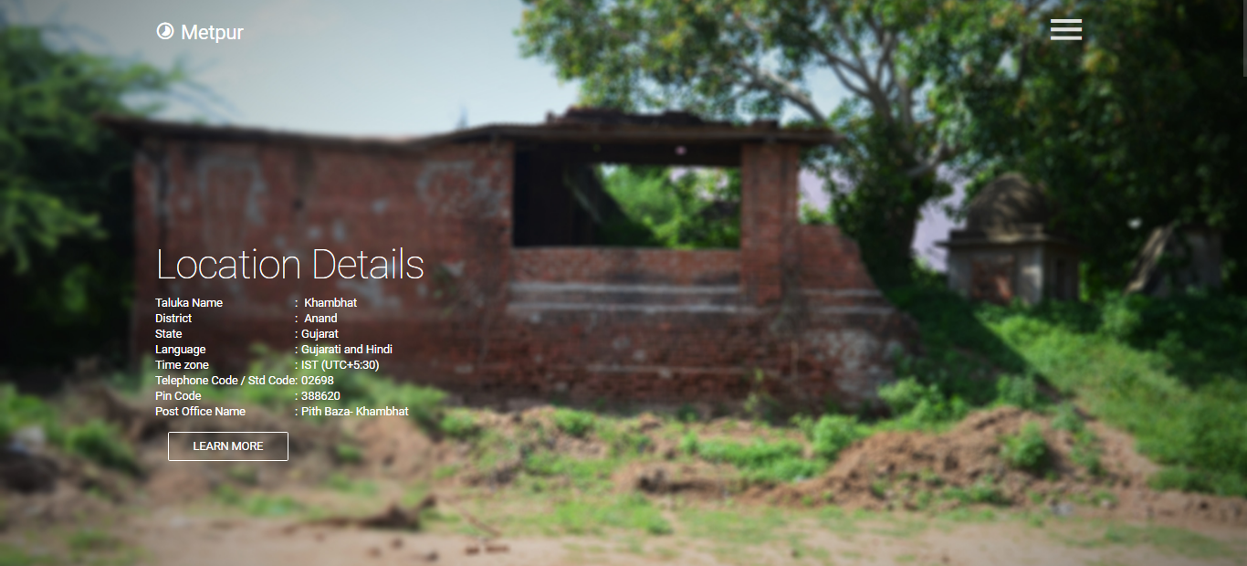

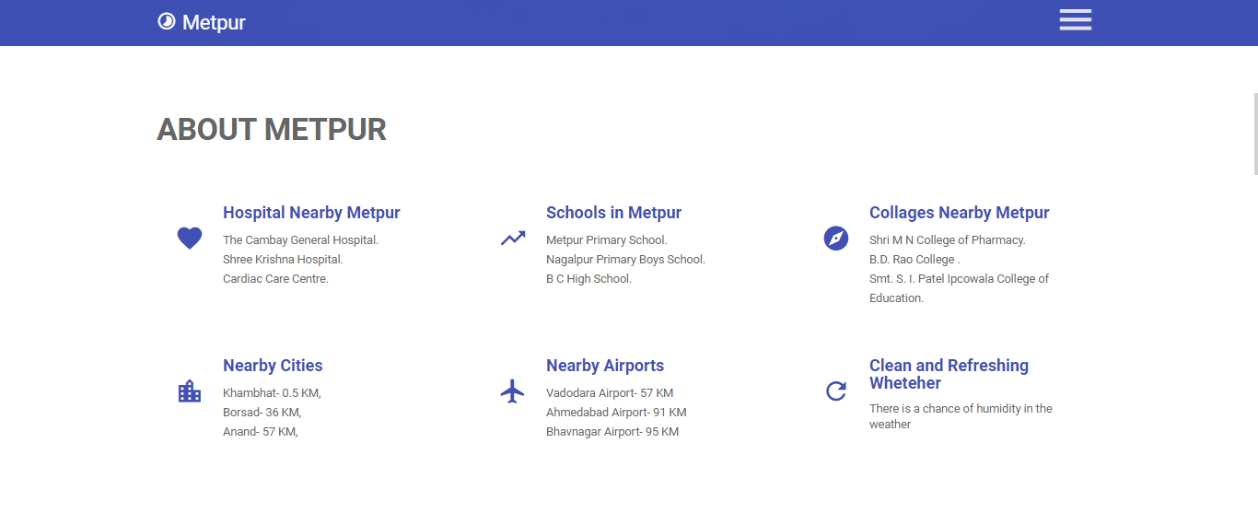

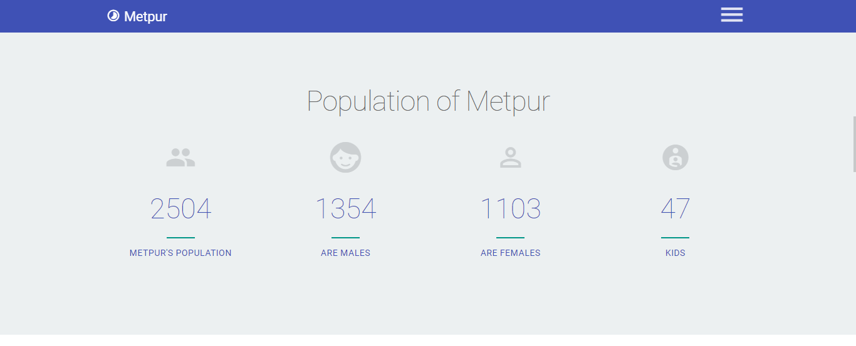

**Embedded Google Map:**

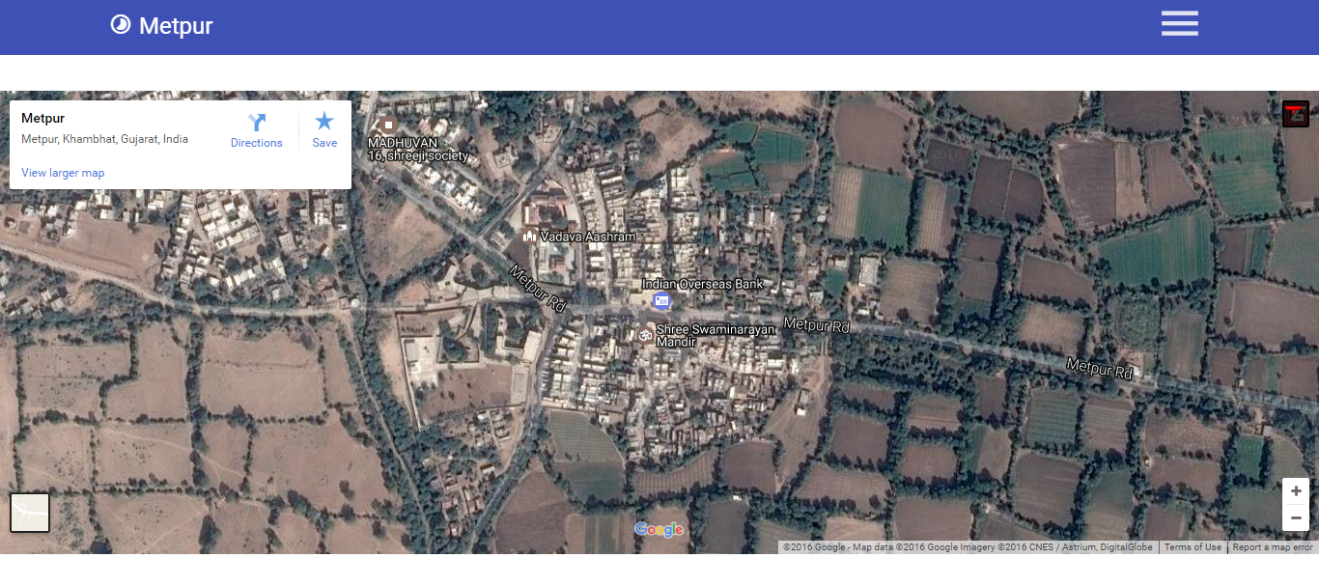

**Slider:**

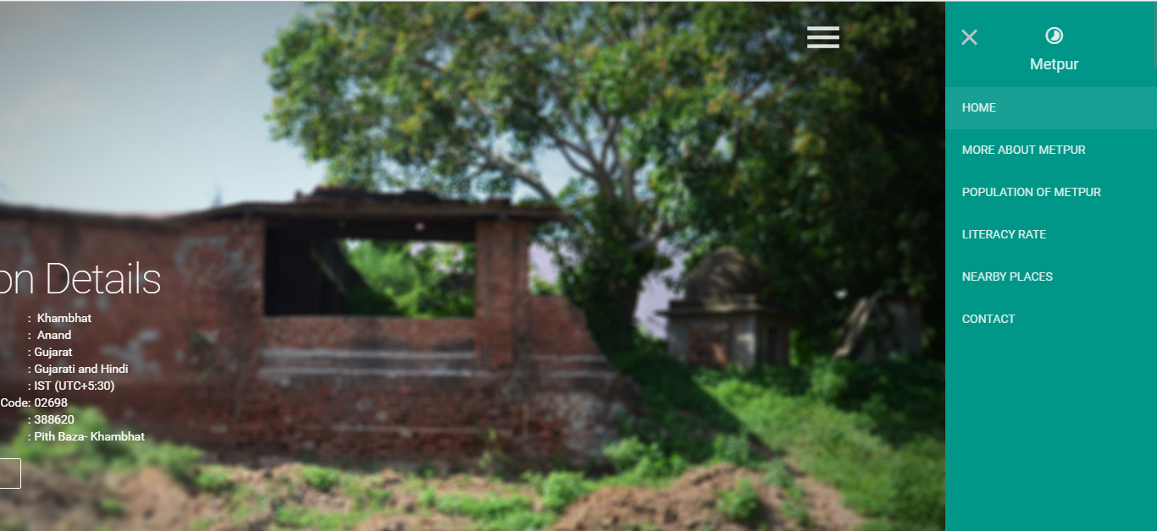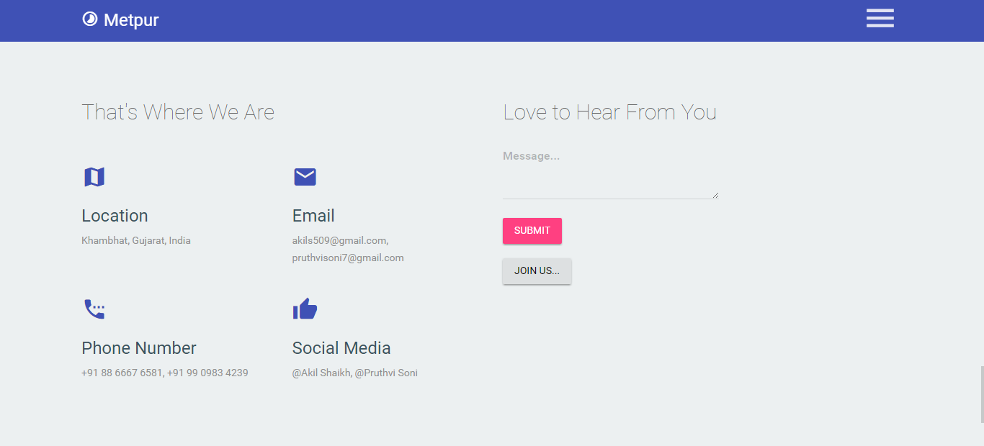

**Login Page:**

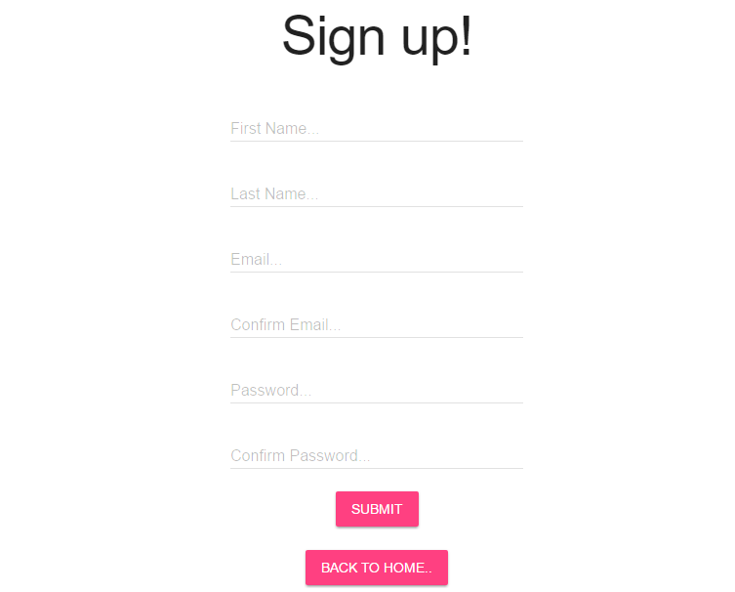

**3.2 Process Phase**

**Administration Side:**

An administrator is a person who is the owner of the website. He can perform the following tasks:-

* Add/Delete information or details.
* Ensure that all information on the website is accurate and up to date.
* To ensure the language and photographs reflect a fair and positive representation to visitor of your website.
* Develop website with links with others.
* Modifying site pages, adding events, and customizing the contact database.

**Administrator Process:**

* Admin logins in the website
* Check whether admin is authorized or not from login database
* If authorized then he gets all his rights
* If unauthorized then the message “Invalid”

**4. Advantages:**

* Get Information about the village at your doorstep
* Publicity and Advertising
* Anyone, Anywhere and Anytime

**5. Future Enhancement:**

* If you see at first glance than you will find it to be almost complete but we want to make it still mature and fully attractive. We want to add some more expansion to my website and the expansion which we thought of are:
* Sign up for the user
* Search module
* E-mail module
* Comment module

**6. Conclusion:**

* By performing this project we have a basic knowledge of how website is created
* How much does it takes
* The Smart Village website has been attempt to help the user and the guest to minimize the workload along with minimizing paper works and saving time.

**Bibliography:**

**Books**

* PHP the complete reference
* PHP with my SQL

**Website:**

* https://villageinfo.in
* http://soki.in/
* <http://www.onefivenine.com/>
* http://www.wikivillage.in/